Stark laser testing plan
Equipment: power detector*2, NI-data acquisition, beam splitter*2, TIReTIP LabVIEW platform, Velemx controller.
- Power measurement
Previous testing:
FIReTIP: pressure 1-4 mTorr, Power 60-70 mW.
Stark laser: pressure 60-80 mTorr, Power 10 mW.
- Frequency shift measurement
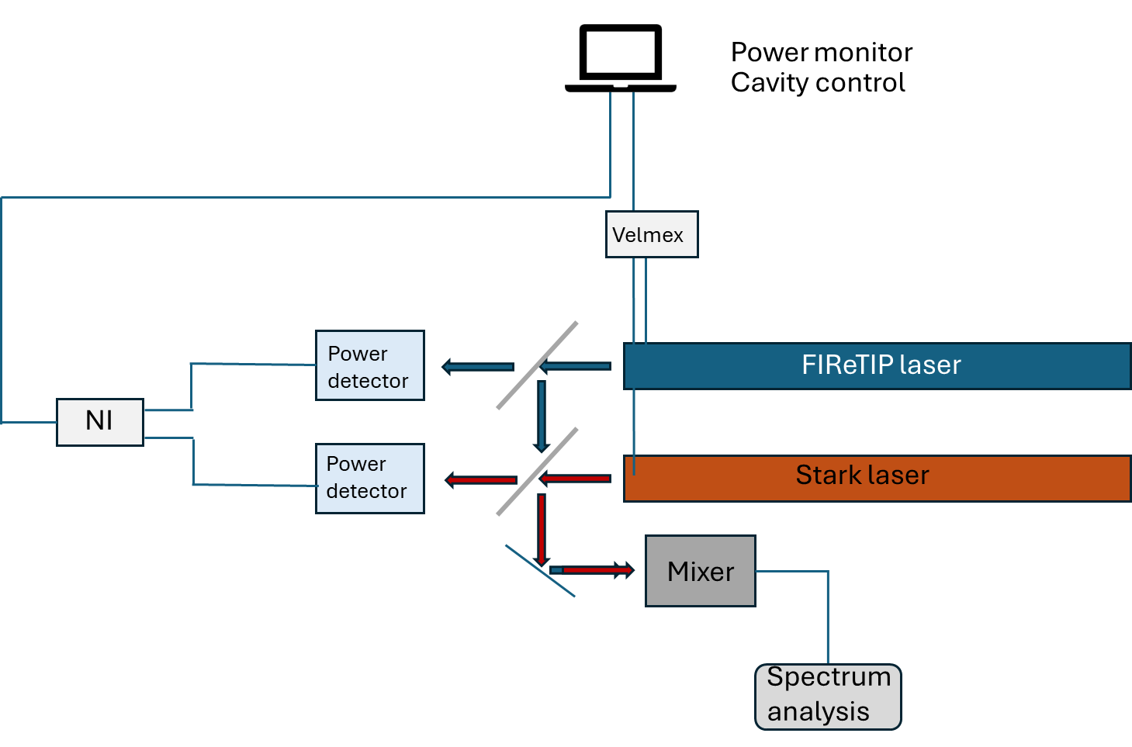

Check the frequency shift under different cavity displacements.
Cavity shift (um) | IF (MHz)
0.16
0.32
0.48
0.64
0.8

Preparations:
- Check the LabVIEW code
- Check the NI DAQ
- Check the power meter
- Check the motor control
- Check the mixer
- Find the attenuator between the mixer and the spectrum analysis.
Frequency shift Assessment:
Consider the main wavelength $λ_{0} corresponding to f_{0}$. when the cavity length of stark laser is adjusted to L₀ to meet the resonant condition, we have
$$\begin{aligned}L_{0}=N\frac{λ_{0}}{2}\#\left(1\right)\end{aligned}$$
Since the FIReTIP frequency bandwidth is about $f_{0}±$2MHz, for wavelength $λ$ slightly away from $λ_{0}$ , if the cavity length is a slightly shifted away from $L_{0}$ but still have the same integer number N at resonant condition, we have
$$\begin{aligned}L=N\frac{λ}{2}\#\left(2\right)\end{aligned}$$
The cavity shift distance is
$$\begin{aligned}Δd=L-L_{0}=\frac{N}{2}\left(λ-λ_{0}\right)\#\left(3\right)\end{aligned}$$
Finally, substituting eq. (1) into eq. (3):
$$\begin{aligned}Δd=-L_{0}\left(1-\frac{λ}{λ_{0}}\right)=-L_{0}\left(1-\frac{f_{0}}{f}\right)=-L_{0}\frac{Δf}{f}=-L_{0}\frac{Δf}{f_{0}+Δf}\#\left(4\right)\end{aligned}$$
where $Δf=f-f_{0}$ , and by expanding Eq. (4) using a Taylor series, we obtain:
$$\begin{aligned}Δd=-L_{0}\frac{Δf}{f_{0}}\left(1+\frac{Δf}{f_{0}}+\frac{1}{2!}{\left(\frac{Δf}{f_{0}}\right)}^{2}+o\left({\left(\frac{Δf}{f_{0}}\right)}^{2}\right)\right)\#\left(5\right)\end{aligned}$$
Since $Δf<1 MHz$ and $f_{0}=2.5THz$, $\frac{Δf}{f_{0}}<1e-6$, so eq. (5) can be simplified to
$$\begin{aligned}Δd=-L_{0}\frac{Δf}{f_{0}}\#\left(6\right)\end{aligned}$$
So the relationship between the cavity shift and the frequency drift is
$$\begin{aligned}Δf=-Δd*\frac{f_{0}}{L_{0}}\#\left(7\right)\end{aligned}$$
Increasing the cavity length would cause a downshift in the frequency.
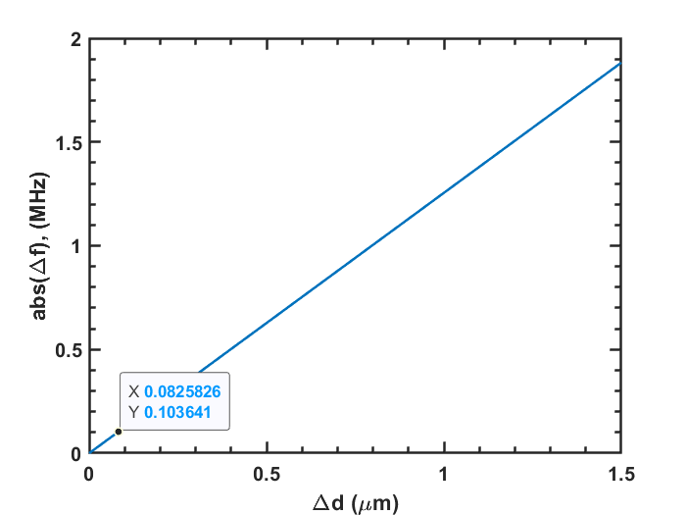
For our system, the $L_{0}≈2m$, $f_{0}≈2.5 THz$, the frequency drift with scanning step size is shown in figure. An increase of 0.1 µm in cavity length can lead to a frequency downshift of approximately 130 kHz. now the minimum cavity scanning step size is 0.16 um.
Moreover, the frequency cannot increase or decrease indefinitely with cavity tuning; the maximum frequency variation is constrained by the spectral bandwidth of methanol gas at 2.5 THz, which is governed by the quantum structure of the gas molecules. Outside of this bandwidth range, there will be no power, or the system may transition into another N±1 resonant condition.

